

Patient Appointment Information
Transmission
(PAIT)

SD*5.3*376

Release Notes

October 2004

Department of Veterans Affairs
VISTA Health Systems Design and Development

Revision History

Date | Revision | Description | Author
9/23/04 | 1.0 | Initial Version | Steve Owen, Ed Wolf, Vasser Lanigan
10/30/04 | 2.0 | Canceled Appointments… added | Ed Wolf
11/2/04 | 3.0 | Changed warning message for runs that have been repaired, updated flow diagram. | Ed Wolf

Table of Contents

Introduction 4
Changes Introduced with Patch SD*5.3*376 5
Combat Veteran Eligibility 6
Combat Veteran End Date 6
Combat Veteran Indication 6
Combat History 6
"Job Started" message on the Forum server. 7
Post-installation updates 7
Clean up file PATIENT APPOINTMENT INFO LOG (#409.6). 7
Outgoing & Upload Statistics Sent via MailMan 8
Provider Name Subcomponent Modifications 8
Interrupted Transmission Repair Process Fix. 8
Automated Verification on the Forum Server 9
More Descriptive Completion Message Text 12
Appointment Selection Logic 12
Patient Class Evaluation 12
Cleaning Process Performed at End of VistA Transmission Task 12
Message for Not Allowing the Manual Transmission of PAIT 12
Protection for Missing Entry in File #409.6 13
Cancelled Appointments for Non-Count Clinics 13
Identifying Appointments in HL7 Messages 14
Field Name Change 14

Introduction
The Chief Business Office (CBO) requested modifications to several Veterans Health Information Systems and Technology Architecture (VistA) packages to support implementation of VHA Directive 2002-049 - "Combat Veterans Are Eligible For Medical Services For 2-Years After Separation From Military Service Notwithstanding Lack Of Evidence For Service Connection", which iterates VA's policy to provide medical care and other medical services to combat veterans despite the absence of proof of service connection. A definition of the Combat Service taken from Attachment A of VHA DIRECTIVE 2004-017, April 2004:

Combat Service - Veterans who served in combat during a period of war after the Gulf War, or against a hostile force during a period of hostilities after November 11, 1998, qualify, and are eligible for hospital care, medical services, and nursing home care for 2 years after discharge from the military for any illness.

Software to support the Combat Veteran (CV) initiative has being developed and introduced in a phased implementation strategy. The Combat Veteran information included in PAIT is evaluated and transmitted based on the already released related patches.

PAIT Automated Verification will track data transmission totals from the initiating site, through the site’s local Vitria Interface Engine, to the centralized Interface Engine at the Austin Automation Center (AAC), and ftp to the AAC MVS mainframe. Totals from each transmission segment are passed to an S.Server option on Forum and stored. Tasked background jobs on Forum will compare totals from each segment of the PAIT and generate MailMan alerts to the National Help Desk (NHD) when a discrepancy or transmission failure is discovered.
Additionally requested enhancements and NOIS response fixes have been rolled into patch SD*5.3*376.
The following diagram depicts the PAIT process at a high level, and includes the modifications from this patch (patch SD*5.3*376)

Note: The data processed from the Patient file # 2 represents appointment created in VistA starting from the next creation date to the last scanned date of the prior transmission. Both final and pending appointments are selected. The Patient Appointment Info Log File #409.6 is scanned for appointments that had been sent already as pending ones, and they are sent again if their current status is final.

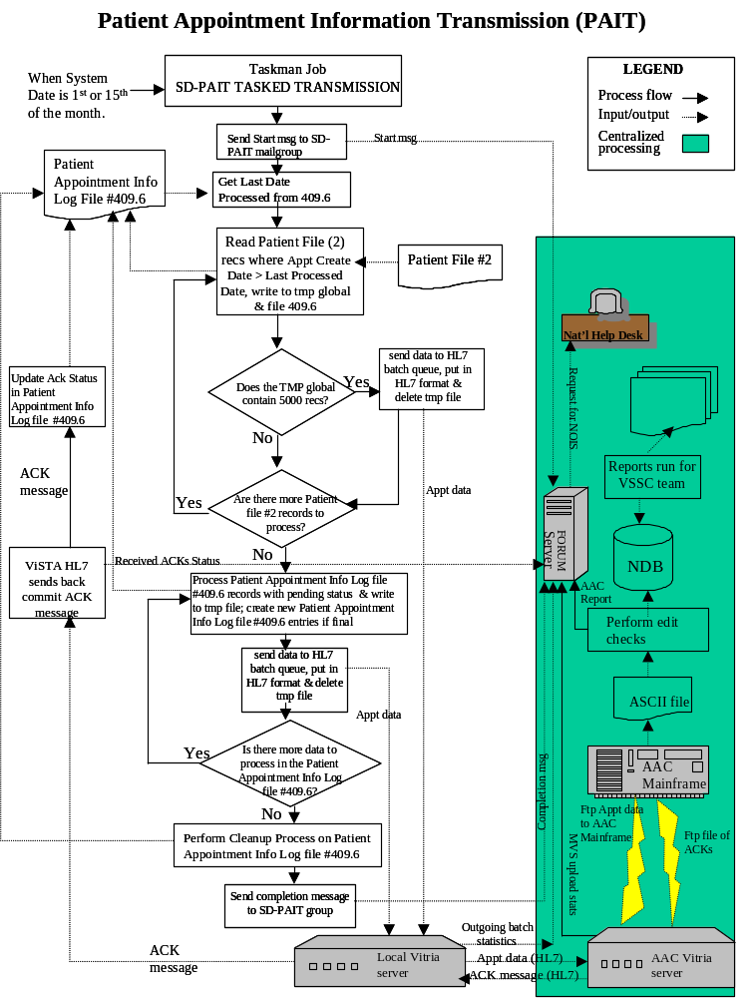

Changes Introduced with Patch SD*5.3*376
The system features delivered with patch SD*5.3*376 include additional data extraction information (Combat Veteran and Military History ) for the National Database, automated verification tools for the Forum Server and software fixes that resolve problems as documented in National Online Information Sharing (NOIS). The following paragraphs describe these changes in further detail.

Combat Veteran Eligibility
Combat Veteran Eligibility is used to identify a Combat Veteran (CV) Status veteran seeking medical care for a specific date. CV eligibility will be determined as of the Appointment Creation Date. The following values for Combat Veteran Eligibility are:

- 1 (Yes) is sent if the patient was/is considered a combat veteran on the Appointment Creation Date;
- 0 (No) is sent if the patient wasn't/isn't considered a combat veteran on the Appointment Creation Date.

Combat Veteran Eligibility is now included in HL7 segment ZEL.

Combat Veteran End Date
The Combat Veteran End Date represents the last day for combat veteran eligibility. The existence of a CV End Date indicates that a veteran has been CV eligible at some point in time. Even if the CV eligibility has expired, this date will still be present. Combat Veteran End Date is now included in HL7 segment ZEL

Combat Veteran Indication
Combat Veteran Indication signifies if an appointment is related to a CV illness/injury. During checkout or during the update of an appointment’s classifications, the question is asked if the appointment was related to the veteran’s CV status. The following values for Combat Veteran Indication are:

- 1 (Yes) is sent if the appointment was related to the veteran’s CV status;
- 0 (No) is sent if the appointment was not related to the veteran’s CV status.

The answer to this question is now included in a seventh repetition of the ZCL HL7 segment (VA Specific Classification).

Combat History
Combat History data is retrieved and transmitted to calculate the waiting time experienced by service members recently returning from the war in Iraq. A new HL7 segment has been implemented (ZMH) to transmit this combat history data to the Austin Automation Center (AAC). Three repetitions of the ZMH segment will be used to transmit the following combat history information:

- Last Service Separation Date
- Combat Veteran Indicated - signifies if the individual was ever considered a Combat Veteran. Valid values are:
  - Y – yes
  - N - no
- Combat Service Location – the location where the individual was in combat. Valid values are:
  - WORLD WAR I
  - WORLD WAR II - EUROPE
  - WORLD WAR II - PACIFIC
  - KOREAN
  - VIETNAM
  - OTHER
  - PERSIAN GULF WAR
  - YUGOSLAVIA CONFLICT
- Persian Gulf Service – indicates if the individual served in the Persian Gulf. Valid values are:
  - Y – yes
  - N – no

"Job Started" message on the Forum server.
A message to the Forum server and a local SD-PAIT Mail Group will now be generated at the beginning of each site’s PAIT transmission to confirm that the bi-monthly data collection process has begun. This start message also details the status of the SD-PAIT logical link and possible reason for any communications error. This message will be sent to the SD-PAIT mail group in the form of a MailMan message. The following is an example of this new Job Started message:

Subj: 500 - PAIT START JOB [#1955884] 09/21/04@12:11 3 lines
From: POSTMASTER In 'IN' basket. Page 1
-------------------------------------------------------------------------------
The PAIT job has started - TASK #: 2717310
Site Started SD-PAIT status Task #
500 |3040921.121119 |Enabled |2717310

The local job completion message will stay as is, with subject 500 - PAIT BACKGROUND JOB, where 500 = station number.

Post-installation updates
Approximately 50% of the sites did not receive initial seeding acknowledgement messages. Sites that did not receive HL7 acknowledgement (ACK) messages during the seeding process due to communication problems will be updated. A post-init routine, working as a driver, will identify a particular site where there is a need to execute the acknowledgement process, by retrieving rejected appointments from routines containing site-specific data only for sites with rejections. Not rejected appointments are processed as acknowledged.
There is a possibility that rejected appointments if originally sent as pending may have already been process.

Clean up file PATIENT APPOINTMENT INFO LOG (#409.6).
Differences between the error report that the site can generate using option: SD-PAIT REJECTED [Rejected Transmission] and the error report coming from the AAC have been identified at some sites. The reason for the current differences is associated with acknowledgements not being received by some sites in a timely manner. Currently, the acknowledgement process initiates cleaning of the previously rejected entries in each site’s PATIENT APPOINTMENT INFO LOG (#409.6) file. Patch SD*5.3*376 will perform a clean-up of all previous entries with the exception of those in pending status so that now the SD-PAIT REJECTED report and AAC Rejected Report will match.

Outgoing & Upload Statistics Sent via MailMan
The Forum Server accepts and processes new completion messages from the VistA Interface Engine and Austin Automation Center. Outgoing batch and MVS upload statistics from the AAC webpage have been merged into mail messages and are transmitted to the Forum Server. The messages are processed and the data used to determine if the transmission process has been completed for each site.

Outgoing batch and MVS upload statistics provided on the AAC webpage will be incorporated into a MailMan message format and transmitted to individuals in the SD-PAIT mail group.

Provider Name Subcomponent Modifications
Previously, if a middle initial and/or a suffix were not identified, the transmitted HL7 AIP segment did not include '~' as the delimiter after the identified First and Last name subcomponents. Tilde (~) delimiters will now be included, even if there is no middle initial and/or no suffix identified. This is acceptable by HL7 standards but was modified on request of Austin Automation Center. For example:

- PROVIDERLAST,PROVIDERFIRST will be transmitted as: PROVIDERLAST~PROVIDERFIRST~~
- PROVIDERLAST,PROVIDERFIRST K JR will be transmitted as: PROVIDERLAST~PROVIDERFIRST~K~JR
- PROVIDERLAST,PROVIDERFIRST K will be transmitted as: PROVIDERLAST~PROVIDERFIRST~K~
- PROVIDERLAST,PROVIDERFIRST JR will be transmitted as: PROVIDERLAST~PROVIDERFIRST~~JR

Interrupted Transmission Repair Process Fix.
For any repair needed to a previously interrupted, not completed transmission, (one where there is not a completion message for a site that had a “job started” message), a message is generated to the National Help Desk requesting a NOIS be created. An additional run must be started by the site to transmit the expected appointments for the current time period. A separate option, SD-PAIT Last Run Repair [SD-PAIT REPAIR] is available. This option must be run before the next transmission is started.

Automated Verification on the Forum Server
Manual checking of batches generated, transmitted, and received is required to ensure each site has completed the bi-monthly transmission. This is time consuming and will be automated. An automated process will be established on the Forum Server that alerts the National Help Desk when any stage of the transmission process fails.

To automate this functionality, new tasked background jobs will be scheduled to run on the Forum Server that incorporate elements from the Vista Interface Engine messaging team (VIE) and the AAC team. VistA IE is expected to report the number of batches received per site, and AAC is expected to report the number of batches received and a total of all received appointments. Any discrepancies with the VistA completion messages will generate warning messages to the National Help Desk

As each site starts and completes designated tasks, a status message will be sent to the Forum Server. Six background tasks will be initiated at scheduled intervals on the Forum Server to determine the status of PAIT at all sites, as follows.

TASK | Schedule 1 | Schedule 2 | Description
PAIT not started | 12:01am 2nd day of month | 12:01am 16th day of month | Generates mail message to National Help Desk listing sites that did not start the scheduled PAIT.
Outgoing IE | 09:00am 3rd day of month | 09:00am 17th day of month | Generates mail message to National Help Desk listing sites where the number of outgoing batches from VistA DOES NOT match the number of outgoing batches from the local interface engine.
PAIT not completed | 09:01am 3rd day of month | 09:01am 17th day of month | Generates mail message to National Help Desk listing sites that have not completed PAIT.
NO ACKs | 12:01am 4th day of month | 12:01am 18th day of month | Generates mail message to National Help Desk listing sites that have not received ANY HL7 acknowledgement messages.
ACKs not completed | 12:01am 4th day of month | 12:01a 18th day of month | Generates mail message to National Help Desk listing sites that have not received ALL HL7 acknowledgement messages.
Uploaded MVS | 09:00am 4th day of month | 09:00am 18th day of month | Generates mail message to National Help Desk listing sites where the number of outgoing batches from Vista, local interface engine, and AAC ftp to MVS mainframe DO NOT match.
Job Complete | 12 Noon 4th day of Month | 12 Noon 18th day of Month | Generates mail message to the National Help Desk listing sites where it compares the Job Complete messages on the Forum Server that DO NOT match AAC Transmitted Sites report.

PAIT not started
From: POSTMASTER@FORUM.VA.GOV [mailto:POSTMASTER@FORUM.VA.GOV]
Sent: Monday, September 20, 2004 2:02 PM
To:
Subject: PAIT NOT STARTED
The following site(s) have not started the bi-monthly PAIT. Please initiate a NOIS for each site referencing the Interface Engine Module:

541 CLEVELAND VAMC
612 NORTHERN CALIFORNIA HCS

PAIT not completed
From: POSTMASTER@FORUM.VA.GOV [mailto:POSTMASTER@FORUM.VA.GOV]
Sent: Monday, September 20, 2004 2:02 PM
To:
Subject: PAIT NOT COMPLETED
The following site(s) have not completed the bi-monthly PAIT background job. Please initiate a NOIS for each site referencing the Interface Engine Module:

541 CLEVELAND VAMC
612 NORTHERN CALIFORNIA HCS

NO ACKs
From: POSTMASTER@FORUM.VA.GOV [mailto:POSTMASTER@FORUM.VA.GOV]
Sent: Monday, September 20, 2004 2:02 PM
To:
Subject: NO ACKNOWLEGEMENTS

The following site(s) have not received ANY acknowledgement
messages for the bi-monthly PAIT. Please initiate a NOIS for
each site referencing the Interface Engine Module:

528 UPSTATE NEW YORK HCS
598 CENTRAL ARKANSAS HCS

ACKs Not Completed
From: POSTMASTER@FORUM.VA.GOV [mailto:POSTMASTER@FORUM.VA.GOV]
Sent: Monday, September 20, 2004 2:24 PM
To:
Subject: ACKNOWLEDGEMENTS NOT COMPLETE

The following site(s) have not received all acknowledgements for
the bi-monthly PAIT. Please initiate a NOIS for each site
referencing the Interface Engine Module:

541 CLEVELAND VAMC
612 NORTHERN CALIFORNIA HCS
657 ST. LOUIS MO VAMC-JC DIVISION

Outgoing IE
From: POSTMASTER@FORUM.VA.GOV [mailto:POSTMASTER@FORUM.VA.GOV]
Sent: Friday, September 17, 2004 9:16 AM
To:
Subject: OUTGOING IE COMPARE

The following sites batch message counts comparing the number sent
from Vista and the number sent from local Interface Engine do not match.
Please initiate a NOIS for each site listed referencing the Interface
Engine Module:

Site # VISTA SENT OUTGOING IE SENT
528 25 26
557 4 8
589 22 23
603 7 8
629 8 9
679 3 16

MVS Upload
From: POSTMASTER@FORUM.VA.GOV [mailto:POSTMASTER@FORUM.VA.GOV]
Sent: Wednesday, September 22, 2004 1:16 PM
To:
Subject: MVS UPLOAD COMPARE

The following sites batch message counts comparing the number sent
from Vista and the number uploaded to MVS do not match. Please
initiate a NOIS for each site listed referencing the Interface
Engine Module:

Site # VISTA SENT MVS UPLOADED
500 1
528 25 26
540 2 4
557 4 8
589 22 23
603 7 8
614 7 8
629 8 9
631 3 4
679 3 15

Job Complete
From: POSTMASTER@FORUM.VA.GOV [mailto:POSTMASTER@FORUM.VA.GOV]
Sent: Wednesday, September 22, 2004 1:16 PM
To:
Subject: JOB COMPLETE COMPARE

The following sites Job Complete messages on the Forum server do not match the AAC Transmitted Sites report. Please initiate a NOIS for each site listed referencing the Interface Engine Module:

528 UPSTATE NEW YORK HCS
598 CENTRAL ARKANSAS HCS

More Descriptive Completion Message Text
More descriptive message text will be added to the various completion message to better inform the user of transmission segment status’ and determine the proper NOIS module to be alerted if a problem occurs. The following new text will be added to the MailMan completion message, when applicable:

- WARNING: TASK STOPPED BY USER, NEEDS TO BE RESTARTED. INITIATE a NOIS TO FOLLOW UP.

- SUCCESS: Transmission completed.

- WARNING: 10 out of 15 still have to be transmitted, please verify with the HL7 System Monitor.

- SD-PAIT Logical Link has to be started.

- Initiate a NOIS for VistA Interface Engine - communication problem.

- WARNING!!!: Transmission of run#: 12 has been repaired. Please create a NOIS to verify if the problem has been addressed

- WARNING!!!: Transmission communication problem, please review.

Appointment Selection Logic
It was discovered there are appointments with NULL creation dates being transmitted. No appointment should have a NULL creation date. NULL creation dates will now be filtered and checked against existing cross-references in the Patient file (#2), so that no appointments with a NULL creation date will be transmitted.

Patient Class Evaluation
Currently, only the Outpatient Encounter file (#409.68) is being used to determine the Patient Class. Sometimes, a NULL value is being transmitted (as ‘U’ – undetermined). Both the Visit (#9000010) and Outpatient Encounter files will now be examined to determine the appropriate Patient Class.

Cleaning Process Performed at End of VistA Transmission Task
The cleaning process of the PATIENT APPOINTMENT INFO LOG file (#409.6) will be moved from the acknowledgement portion of processing to the end of the main transmission processing, and will be independent of the acknowledgements processing.

Message for Not Allowing the Manual Transmission of PAIT
When the SD-PAIT TASKED TRANSMISSION is scheduled and the site attempts to run the SD-PAIT MANUAL TRANSMISSION option, the software completes a check prior to allowing the manual option to run in order to determine if the tasked job is scheduled; however, currently the code does not notify the user as to the reason it will not allow queuing.

If this situation occurs, an informational message will be displayed on the screen, immediately letting the user know why the manual transmission will not be run and also a MailMan message sent to the user explaining why queuing of the manual option: SD-PAIT MANUAL TRANSMISSION is not allowed.

The following is an example of this message received on the screen:

Select OPTION NAME: SD-PAIT MANUAL TRANSMISSION Manual Startup PAIT Transmission

Manual Startup PAIT Transmission
You attempted to start PAIT outside the authorized transmission dates.
Job has been terminated.

The following is an example of the MailMan message received by a user who tried to execute the manual transmission when the regular tasked transmission is scheduled:

Subj: PAIT Transmission [#1955781] 09/17/04@13:50 3 lines
From: POSTMASTER In 'IN' basket. Page 1 *New*
-------------------------------------------------------------------------------
USERLASTNAME,USER (DUZ=100106) attempted to start the PAIT transmission
on Sep 17, 2004@13:50:39, outside the authorized transmission dates.
The job has been cancelled

Protection for Missing Entry in File #409.6
Protection will now be provided for a missing entry in the PATIENT APPOINTMENT INFO LOG file (#409.6) where an "AE" Retention Flag cross reference with a “Y” value exists, while scanning previously sent appointments.
If the entry does not exist, then the cross reference pointing to it will be deleted.

Cancelled Appointments for Non-Count Clinics
Currently, if an appointment is created and then cancelled its status as a count or non-count clinic is not known. Now, additional verification is performed to determine the clinic type for canceled appointments, and if the clinic is 'NON-COUNT' it will receive 'NC' as its appointment type on the HL7 SCH message segment if it is not rescheduled, or an ‘RSN’ as its appointment type on the HL7 SCH message segment for appointments that are rescheduled.

Identifying Appointments in HL7 Messages
The new option Patient HL7 Location [SD-PAIT PATIENT HL7 LOCATION] lists HL7 message number and sequence for a specified appointment date/time. This is useful for verification of generated and transmitted data for a particular appointment.

Field Name Change

The name of sub field #2 of Patient field #2 was changed from HL7 BATCH # to HL7 MESSAGE ID.

Canceled Terminated Evaluation Modification

If an appointment is canceled and another one is scheduled for the same Appointment Date/Time, then the previous one’s Event Reason will be Canceled Terminated, regardless of whether it was already canceled and transmitted in a previous run or if it was cancelled and transmitted in the current run with the new appointment that has the same Appointment Date/Time. This situation is automatically recognized when appointments have the same Appointment Date/Time, but different Creation Dates. The original Creation Date is retrieved from the PATIENT APPOINTMENT INFO LOG file 409.6, then overwritten in VistA by the Creation Date of the new appointment that has the same Appointment Date/Time.

